**SOFTWARE REQUIREMENT SPECIFICATION**

**DOCUMENT**

**E – CALCULATOR APPLICATION**

**Version:** Version 2.0



**ABSTRACT**

This document is intended to be the SRS for develop **E – CALCULATOR APPLICATION**



| **Project Title** | **E – CALCULATOR APPLICATION** | | |
| --- | --- | --- | --- |
| **Lead Institution** | **THE INTERNATIONAL SCHOOL - DUY TAN UNIVERSITY** | | |
| **Project Mentor** | **Mr. Nguyen Dang Quang Huy** | | |
| **Team Name** | **Team 5** | | |
| **Team Members** | **Tran Quy** | | |
| **Tran An Thuyen** | | |
| **Tran Thi Thuy Duong** | | |
| **Le Minh Tuan** | | |
| **Nguyen Anh Huy** | | |
|  | | |
| **Start Date** | Jan 25th, 2024 | **End Date** | Feb 22th, 2024 |

**ROPRIETARY INFORMATION**: The information contained in this document is the property of **TEAM 5**. Except as specifically authorized in writing by **TEAM 5**, the holder of this document shall keep all information contained herein confidential and shall protect same in whole or in part from disclosure and dissemination to all third parties

**Table of Contents**

Revision History 3

1. Introduction 5

1.1. Purpose 5

1.2. Intended Audience and Reading Suggestions 5

1.3. References 5

2. Project Overview 5

2.1. Project Description 5

A calculator application is a basic project that can be developed using various programming languages platforms. Here’s a general description of a calculator application: 5

Functionality: The application performs basic arithmetic operations like addition, subtraction, multiplication, and division. Some calculators can also perform more advance operations such as diving by residual calculation. 5

User interface: The user interface consists of numeric buttons (0 – 9) and arithmetic operations buttons (+, -, *, /, %). 5

Display: The calculator has a display screen that shows the mathematical expression and the result. 5

2.2. Business Need 6

2.3. Project Analyst 6

2.3.1. Business Function Diagram 6

2.3.2. System Context Diagram 7

2.4. Software Requirement Specification 8

2.4.1. High level Functional Requirement (FR) 8

2.4.2. Stakeholders 9

2.4.3. Use case 9

2.4.4. List of use case 9

2.4.5. Use Case Specification 10

UC.01: Enter 2 numbers a and b: 10

UC.02: Select the math operation: 10

UC.03: See result: 11

UC.04: Delete data: 12

UC.05: Performs Mathematical Operations and Display result: 13

2.4.6. Activity Diagrams 14

Enter 2 numbers a and b: 14

Select the math operation: 15

See result: 15

Delete data: 16

Performs Mathematical Operations and Display result: 16

Appendix A: Glossary 17

# Revision History

| **Date** | **Change Iterm** | **Description** | **By** | **Version** |
| --- | --- | --- | --- | --- |
| **26/1/2024** | Get requests from customers | After preparing the questions about the request and received the request from the customer | Tran Quy | Version 1.0 |
| **26/1/2024** | Start team meeting | Meet and refer to a number of training points, read through the training points and focus on project implementation, the team can fully understand the system requirements to create | Tran Quy, Tran An Thuyen, Tran Thi Thuy Duong, Le Minh Tuan, Nguyen Anh Huy | Version 1.0 |
| **26/1/2024** | Job analysis | Through specific requirements, analysis, clearly speaking, the leader needs to prepare in advance for the members. | Tran Quy | Version 1.0 |
| **27/1/2024** | Share the work | Get BFD, contextual diagram,  The mandatory rules of the project | Tran Quy, Tran An Thuyen, Tran Thi Thuy Duong, Le Minh Tuan, Nguyen Anh Huy | Version 1.0 |
|  | Mr. Huy corrected | Fix BFD, USE CASE, font size, font pattern, context diagram, more clearly about the missing and suggest some important things | Tran Quy | Version 1.0 |
| **29/1/2024** | Editing group | BFD, USE CASE, Context Diagram, font size, font | Tran Quy, Tran An Thuyen, Tran Thi Thuy Duong, Le Minh Tuan, Nguyen Anh Huy | Version 1.0 |
| **29/1/2024** | Complete System Context Diagram | System Context Diagram | Tran Quy, Tran An Thuyen, Tran Thi Thuy Duong, Le Minh Tuan, Nguyen Anh Huy | Version 2.0 |

# Introduction

## Purpose

This documentation describes a calculator application that includes the calculations required for the user. The purposes of this document are as below:

* Support for users in easy calculations.
* Help save time and increase accuracy in calculations.
* It also supports users in a certain job.

## Intended Audience and Reading Suggestions

| Intended Audience | Reading Suggestions |
| --- | --- |
| Project manager | High level functional requirement, business constraints for estimation |
| Architect analyst and designer | Overall description and user cases to architect and design the system |
| Quality control | Overall description and user cases to make test plan and write acceptance test |

## References

# Project Overview

## Project Description

## A calculator application is a basic project that can be developed using various programming languages platforms. Here’s a general description of a calculator application:

## Functionality: The application performs basic arithmetic operations like addition, subtraction, multiplication, and division. Some calculators can also perform more advance operations such as diving by residual calculation.

## User interface: The user interface consists of numeric buttons (0 – 9) and arithmetic operations buttons (+, -, *, /, %).

## Display: The calculator has a display screen that shows the mathematical expression and the result.

## Business Need

**Function:**

- Enter 2 numbers.

- Perform mathematical operations: addition, subtraction, multiplication, division, division for the remainder.

- Display the result.

- Delete imported data.

**Non - Function:**- Performance: The application must respond quickly; no delays are allowed.

- Interface: Easy to see, easy to use.

- Reliability: The app must give accurate results.

## Project Analyst

### Business Function Diagram

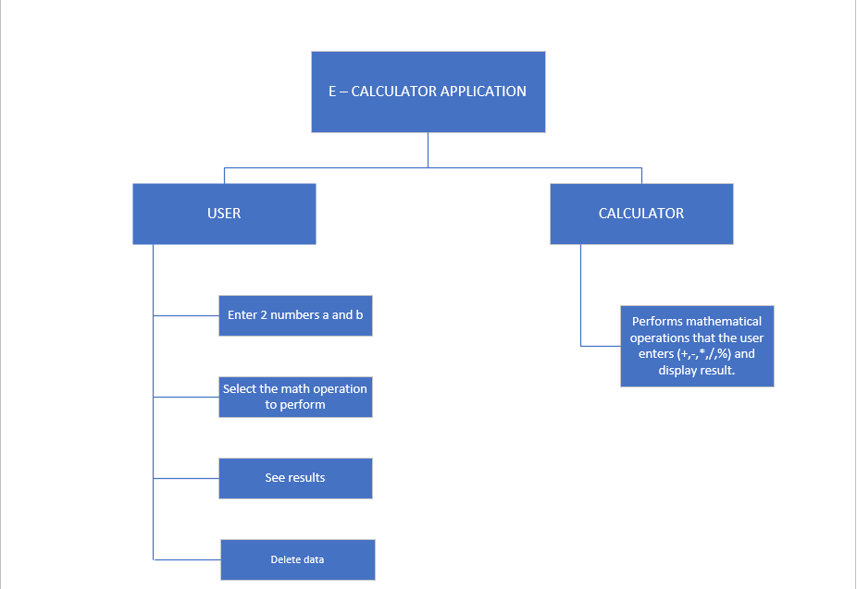

### System Context Diagram

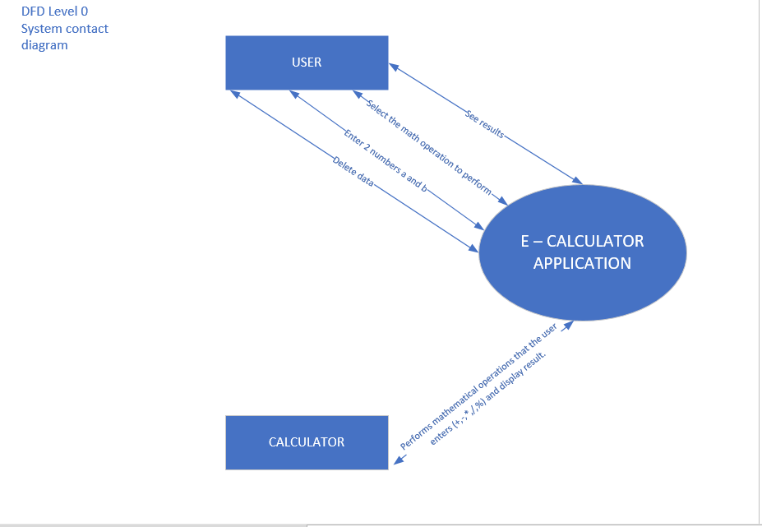

## Software Requirement Specification

### High level Functional Requirement (FR)

| FR1.1 | **Title** | **Enter 2 numbers a and b** |
| --- | --- | --- |
| All users | All users enter two numbers, a and b, in preparation for subsequent operations. |
| Description | All users will enter two numbers, a and b, through a user interface. This interface can consist of two input fields, each corresponding to a number. The user enters numbers from the keyboard or selects from a list of available numbers. |
| FR1.2 | **Title** | **Select the math operation** |
| All users | All users select one of the basic mathematical operations (addition, subtraction, multiplication, division, modulus) to perform with two entered numbers. |
| Description | After entering two numbers, the user selects an operation to perform. Options can include addition, subtraction, multiplication, division, modulus. The user will select the operation from a dropdown list or by clicking on one of the buttons corresponding to each operation. |
| FR1.3 | **Title** | **See result** |
| All users | All users see results after performing with two entered numbers. |
| Description | After the user selects the operation, the system performs the operation on the two entered numbers and displays the result to the user. The result will be displayed on the screen in a separate result pane. |
| FR1.4 | **Title** | **Delete data** |
| All users | All users can delete the entered numbers and current result to start a new mathematical operation. |
| Description | If users want to perform a new mathematical operation, they can delete the entered numbers and the current result. This can be done by clicking on a button "Clear". |
| FR1.5 | **Title** | **Performs Mathematical Operations and Display result** |
| Calculator | The system performs basic mathematical operations (addition, subtraction, multiplication, division, modulus) on two entered numbers and displays the result of the mathematical operation performed on two entered numbers. |
| Description | The system will perform basic mathematical operations (addition, subtraction, multiplication, division, modulus) on two entered numbers. This will be done automatically after the user selects the operation. After the system performs the operation, the result will be displayed to the user. The result will be displayed in a separate result pane on the screen, allowing users to easily see the result of the operation they selected. |

### Stakeholders

| **Stakeholder** | **Description** |
| --- | --- |
| Users | System users |
| Calculator | System |

### Use case

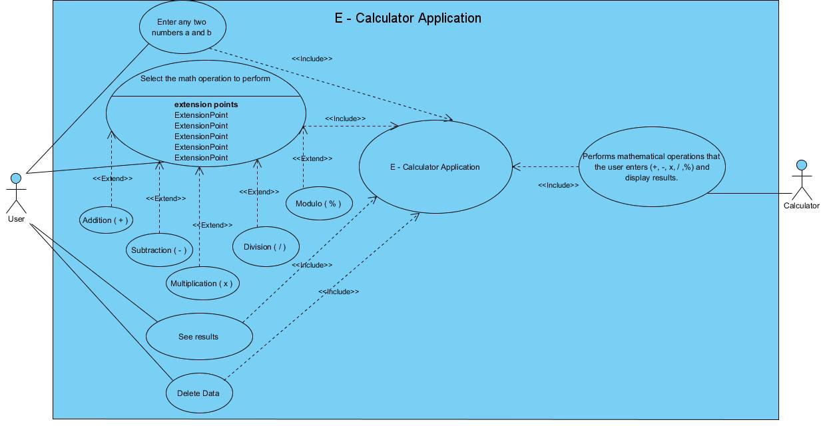

### List of use case

| **Use case ID** | **Use case name** | **Functional Req.** |
| --- | --- | --- |
| UC.01 | Enter 2 numbers a and b | FR1.1 |
| UC.02 | Select the math operation | FR1.2 |
| UC.03 | See result | FR1.3 |
| UC.04 | Delete data | FR1.4 |
| UC.05 | Performs Mathematical Operations and Display result | FR1.5 |

### Use Case Specification

##### UC.01: Enter 2 numbers a and b:

| Use case ID | UC.01 | | | | |
| --- | --- | --- | --- | --- | --- |
| Use case name | **Enter any two numbers A and B.** | | | | |
| Create by | Anh Huy | | **Last updated by** | | Anh Huy |
| Date created | Jan 28, 2024 | | **Date last updated** | | Jan 29, 2024 |
| Actor | All users of the system. | | | | |
| Description | This use case allows users to enter 2 numbers a and b into the system. | | | | |
| Pre-condition | Users must select the application. | | | | |
| Post-condition | If the numbers a and b are valid, then the application will store these two numbers. If the number a or b is invalid, then the application displays an error message. | | | | |
| Main Success Scenario: | **Step** | **Actor Action** | | **System Response** | |
| 1 | Users select the E – Calculator Application. | |  | |
| 2 |  | | System opens the E – Calculator Application. | |
| 3 |  | | System shows calculations (+, -, *, /, %). | |
| 4 | Users enter any number a and b. | |  | |
| 5 |  | | Test system number a and b | |
| 6 |  | | Number display system a and b. | |
| Alternative Scenario | **Step** | **Actor Action** | | **System Response** | |
| 5.1 |  | | System displays an error message. | |
| 5.2 | Users confirm the choice to go back. | |  | |
| 5.3 |  | | System goes back to step 2 (System Response). | |
| Exception | **Step** | **Actor Action** | | **System Response** | |
|  |  | |  | |

##### UC.02: Select the math operation:

| Use case ID | UC.02 | | | | |
| --- | --- | --- | --- | --- | --- |
| Use case name | **Select the math operation.** | | | | |
| Create by | Anh Huy | | **Last updated by** | | Anh Huy |
| Date created | Jan 28, 2024 | | **Date last updated** | | Jan 29, 2024 |
| Actor | All users of the sytem. | |  | | |
| Description | Allows users to select the operation to perform on two numbers a and b that have been entered. | | | | |
| Pre-condition | Users has entered the application and performed calculations. | | | | |
| Post-condition | The Calculator application has performed the selected operation on two numbers a and b. | | | | |
| Main Success Scenario: | **Step** | **Actor Action** | | **System Response** | |
| 1 | Users have entered the system. | |  | |
| 2 |  | | Number display system (0-and calculations (+, -, *, /, %). | |
| 3 | Users enter any number a and b. | |  | |
| 4 |  | | Test system number a and number b. | |
| 5 | Users select calculation (+, -, *, /, %) | |  | |
| 6 | Users click the "**Calculate**" button | |  | |
| 7 |  | | System displays the result. | |
| Alternative Scenario | **Step** | **Actor Action** | | **System Response** | |
| 4.1 | Users enter invalid numbers. | |  | |
| 4.2 |  | | Notification system and confirmation requests. | |
| 4.3 | Users Confirmation. | |  | |
| 4.4 |  | | The system goes back to step 1 (System Response). | |
| Exceptions | **Step** | **Actor Action** | | **System Response** | |
|  |  | |  | |
|  |  | |  | |

##### UC.03: See result:

| Use case ID | UC.03 | | | | |
| --- | --- | --- | --- | --- | --- |
| Use case name | **See result.** | | | | |
| Create by | Anh Huy | | **Last updated by** | | Anh Huy |
| Date created | Jan 28, 2024 | | **Date last updated** | | Jan 29, 2024 |
| Actor | All users of the sytem. | |  | | |
| Description | Allows users to see the result of the operation that has been performed. | | | | |
| Pre-condition | The Calculator app has been launched.  - Two numbers a and b have been entered into the application.  - The math has been chosen. | | | | |
| Post-condition | The Calculator app has displayed the results of the operation. | | | | |
| Main Success Scenario: | **Step** | **Actor Action** | | **System Response** | |
| 1 | Users enter numbers a and b. | |  | |
| 2 |  | | System checks the entered numbers. | |
| 3 | Users select the calculation. | |  | |
| 4 |  | | System performs calculations | |
| 5 |  | | System displays the results to the screen. | |
| 6 | Users view the result and finishes. | |  | |
| Alternative Scenario | **Step** | **Actor Action** | | **System Response** | |
| 2.1 |  | | System notifies incorrectly entered user numbers. | |
| 2.2 | Users perform the data entry process again. | |  | |
|  |  | |  | |
| Exceptions | **Step** | **Actor Action** | | **System Response** | |
|  |  | |  | |
|  |  | |  | |

##### UC.04: Delete data:

| Use case ID | UC.04 | | | | |
| --- | --- | --- | --- | --- | --- |
| Use case name | **Delete data.** | | | | |
| Create by | Anh Huy | | **Last updated by** | | Anh Huy |
| Date created | Jan 28, 2024 | | **Date last updated** | | Jan 29, 2024 |
| Actor | All users of the sytem. | |  | | |
| Description | Allows users to delete input data for subsequent operations. | | | | |
| Pre-condition | The Calculator app has been launched.  - Two numbers a and b have been entered into the application. | | | | |
| Post-condition | The input data has been deleted. | | | | |
| Main Success Scenario: | **Step** | **Actor Action** | | **System Response** | |
| 1 | Users open the calculator application. | | . | |
| 2 |  | | System displays the application page | |
| 3 | Users enter the numbers a and b. | |  | |
| 4 | Users choose the calculation (+, -, *, /, %) | | . | |
| 5 | Users click the "**Clear**" button | |  | |
| 6 |  | | System deletes the entered and selected values | |
| Alternative Scenario | **Step** | **Actor Action** | | **System Response** | |
| 5.1 | If users haven't entered any values yet. | |  | |
| 5.2 |  | | System does not take any action. | |
|  |  | |  | |
| Exceptions | **Step** | **Actor Action** | | **System Response** | |
|  |  | |  | |
|  |  | |  | |

##### UC.05: Performs Mathematical Operations and Display result:

| Use case ID | UC.05 | | | | |
| --- | --- | --- | --- | --- | --- |
| Use case name | **Performs Mathematical Operations and Display result.** | | | | |
| Create by | Anh Huy | | **Last updated by** | | Anh Huy |
| Date created | Jan 28, 2024 | | **Date last updated** | | Jan 29, 2024 |
| Actor | The Calculator Sytem. | |  | | |
| Description | Allows users to perform mathematical operations on two entered numbers a and b. | | | | |
| Pre-condition | The Calculator app has been launched. | | | | |
| Post-condition | The Calculator application has performed the entered operation and displays the result. | | | | |
| Main Success Scenario: | **Step** | **Actor Action** | | **System Response** | |
| 1 | Users open the Calculator application. | |  | |
| 2 | Users enter the numbers a and b. | |  | |
| 3 |  | | System checks the numbers a and b. | |
| 4 | Users select the calculations (+, -, *, /, %). | |  | |
| 5 |  | | System performs calculations. | |
| 6 |  | | System displays the results to the screen. | |
| 7 | Users view the result and finishes. | |  | |
| Alternative Scenario | **Step** | **Actor Action** | | **System Response** | |
| 3.1 |  | | System notifies incorrectly entered user numbers. | |
| 3.2 | Users perform the data entry process again. | |  | |
| 5.1 |  | | System informs the user to select error calculations and do it again. | |
| 5.2 | Users repeat step 4 (Actor Action). | |  | |
| Exceptions | **Step** | **Actor Action** | | **System Response** | |
|  |  | |  | |
|  |  | |  | |

## 2.4.6. Activity Diagrams

## Enter 2 numbers a and b:

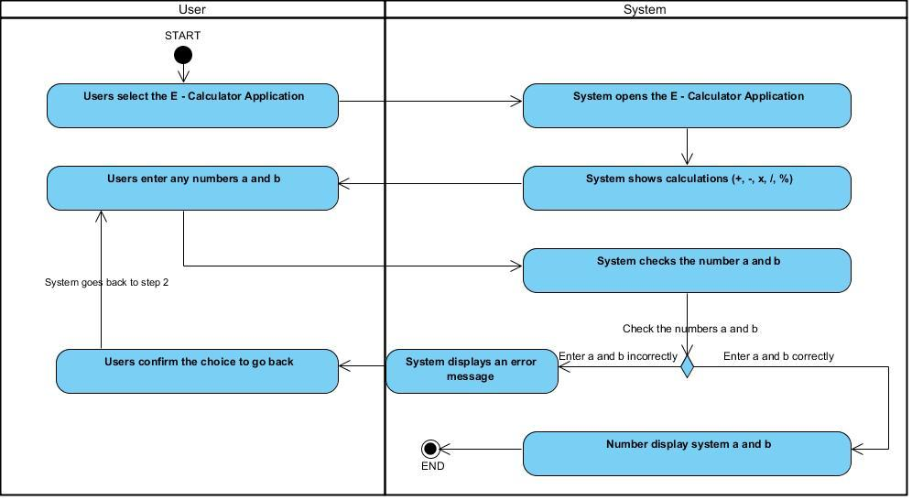

## Select the math operation:

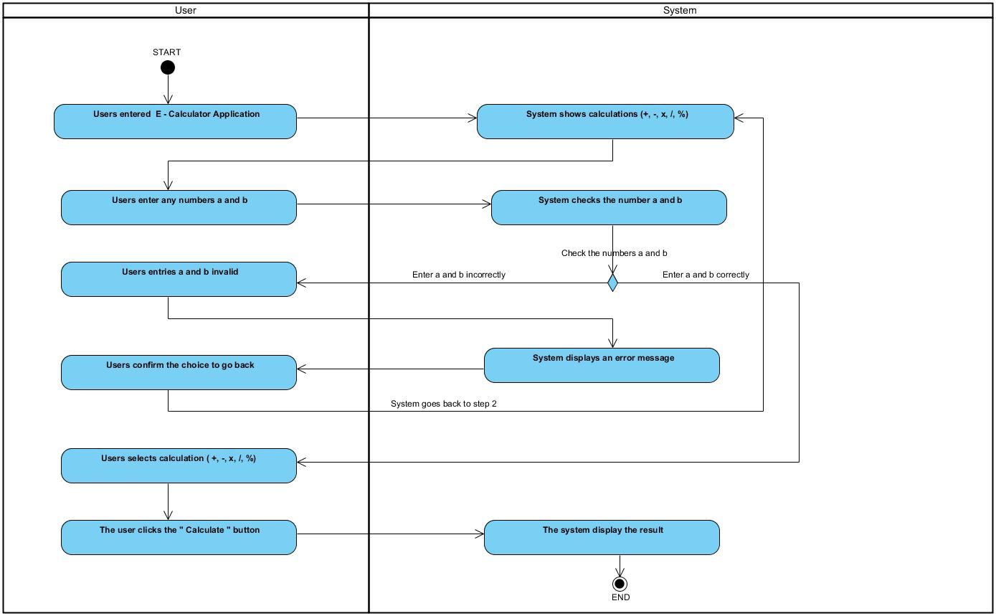

## See result:

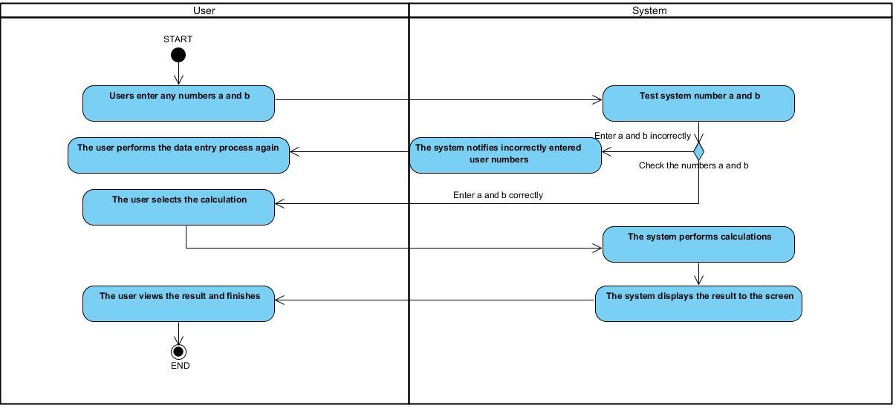

## Delete data:

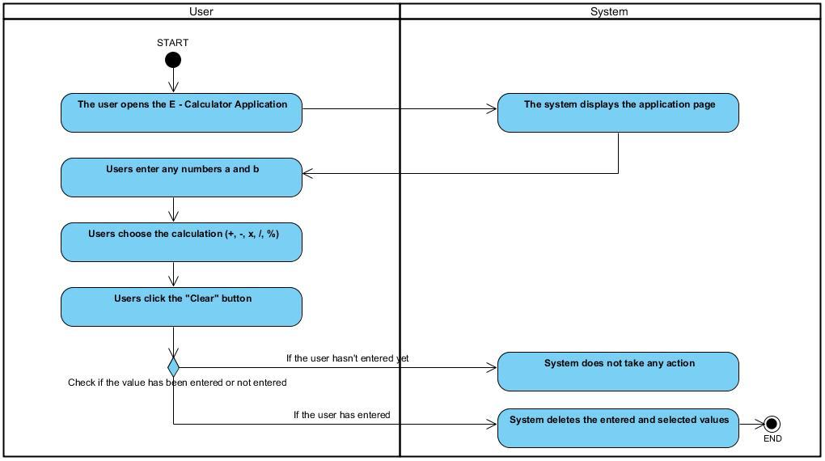

## Performs Mathematical Operations and Display result:

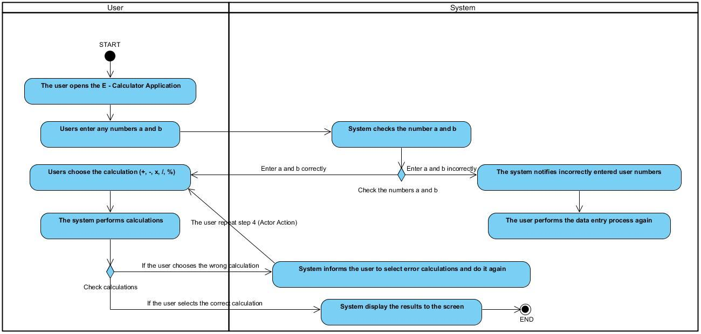

# Appendix A: Glossary

| FR | Functional Requirement |
| --- | --- |
| QA | Quality Attribute |
| UC | Use case |
| BR | Business rule |